

Practices for Secure Software Report

Table of Contents
Document Revision History 3
Client 3
Instructions 3
Developer 4
1. Algorithm Cipher 4
2. Certificate Generation 4
3. Deploy Cipher 4
4. Secure Communications 4
5. Secondary Testing 4
6. Functional Testing 4
7. Summary 4
8. Industry Standard Best Practices 4

Document Revision History

Version | Date | Author | Comments
1.0 | [4/17/26] | [Chris Banos]

Client



Instructions

Submit this completed practices for secure software report. Replace the bracketed text with the relevant information. You must document your process for writing secure communications and refactoring code that complies with software security testing protocols.

- Respond to the steps outlined below and include your findings.
- Respond using your own words. You may also choose to include images or supporting materials. If you include them, make certain to insert them in all the relevant locations in the document.
- Refer to the Project Two Guidelines and Rubric for more detailed instructions about each section of the template.

Developer
[Chris Banos]

Algorithm Cipher

[For this project, the SHA-256 cryptographic hash algorithm was selected to provide secure data verification through checksum generation. SHA-256 is part of the SHA-2 family of hashing algorithms and produces a 256-bit fixed-length output.

SHA-256 is a one-way hash function, meaning that it cannot be reversed to retrieve the original input data. This makes it ideal for ensuring data integrity during transmission. If even a single character in the input changes, the resulting hash will be completely different.

The algorithm operates at a 256-bit level, providing a strong level of security against collision attacks. It uses deterministic processing but incorporates complex mathematical transformations and bitwise operations to produce a unique output.

Unlike symmetric and asymmetric encryption, SHA-256 does not use keys for encryption or decryption. Instead, it is used strictly for hashing and verification purposes. However, it plays a critical role in secure communication systems when combined with encryption protocols.

Historically, earlier hashing algorithms such as MD5 and SHA-1 were widely used but are now considered insecure due to vulnerabilities and collision attacks. SHA-256 is currently considered secure and is widely used in modern applications, including SSL/TLS certificates and blockchain technologies.

Overall, SHA-256 was chosen because it provides a strong, industry-standard method for ensuring data integrity and secure communication within the application.]

Certificate Generation
Insert a screenshot below of the CER file.

[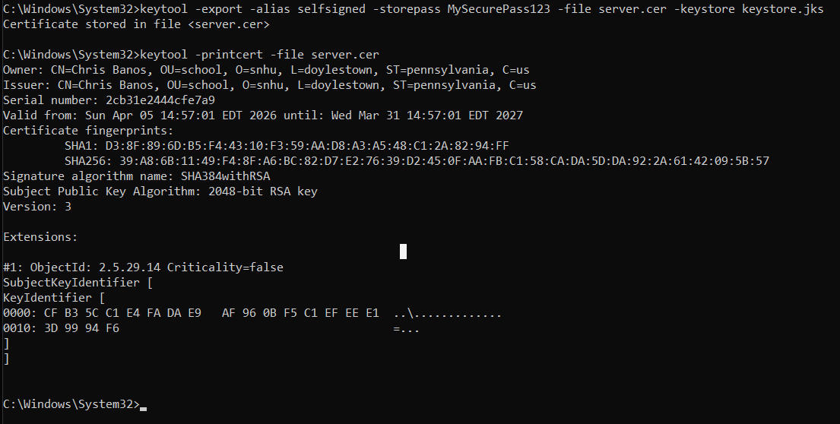]

Deploy Cipher
Insert a screenshot below of the checksum verification.

[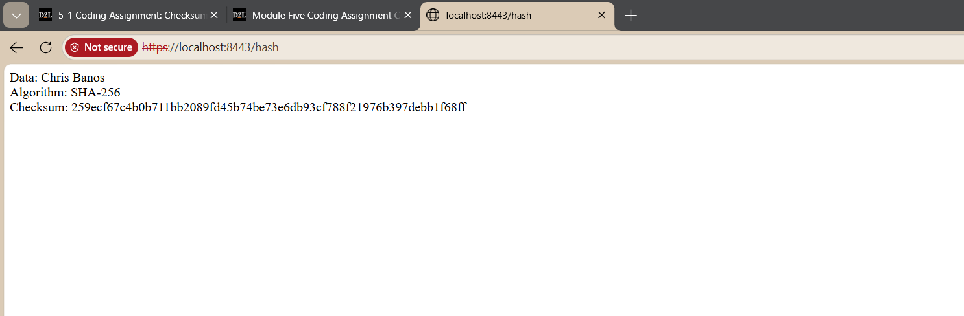]

Secure Communications
Insert a screenshot below of the web browser that shows a secure webpage.

[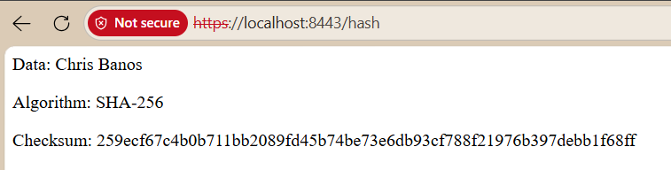]

Secondary Testing
Insert screenshots below of the refactored code executed without errors and the dependency-check report.

[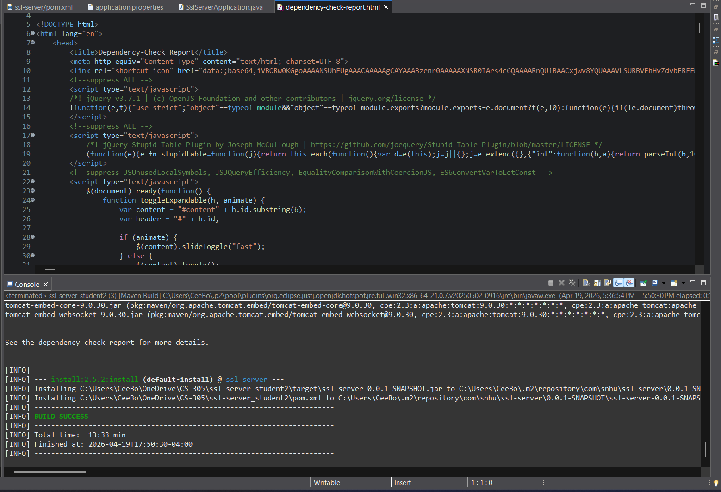]

Functional Testing
Insert a screenshot below of the refactored code executed without errors.

[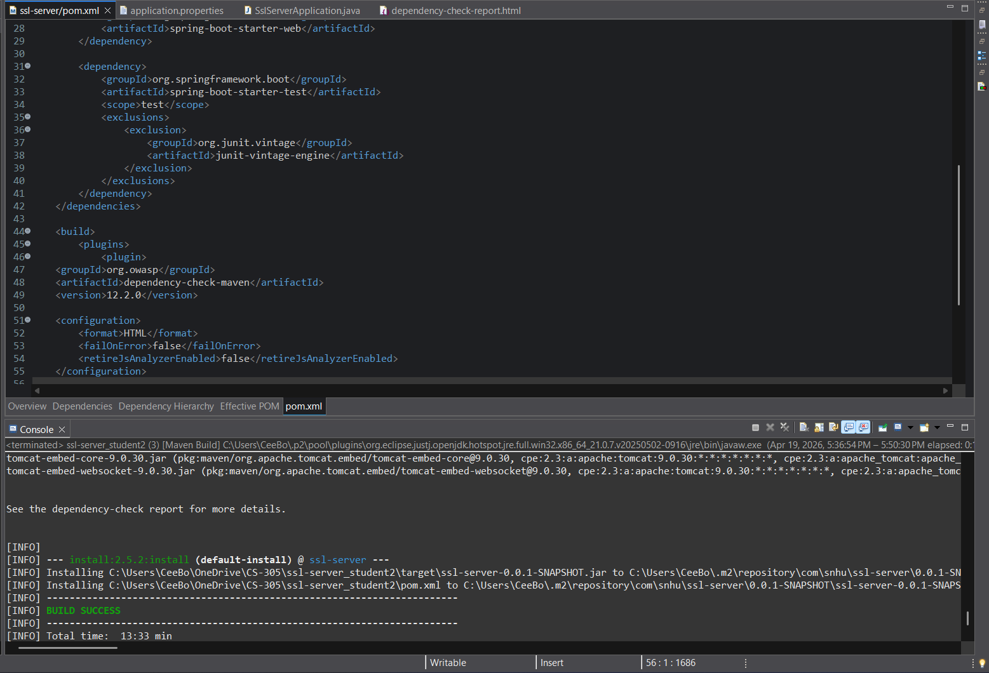]

Summary

[The application was refactored to improve secure communication and data integrity for Artemis Financial. Security enhancements included implementing a SHA-256 checksum feature, generating and exporting a self-signed certificate, and configuring the application to use HTTPS.

These changes addressed key areas of the vulnerability assessment process, including secure transmission of data and verification of data integrity. Additional layers of security were added by combining encryption, hashing, and secure communication protocols.

Testing was performed using both manual functional testing and the OWASP dependency-check tool to ensure that the refactored code executed without errors and did not introduce new vulnerabilities. The final application successfully demonstrated secure communication and checksum verification as required.]

Industry Standard Best Practices

[Industry standard best practices were applied throughout the development process to improve the security of the application. These included using a modern hashing algorithm (SHA-256), enabling HTTPS communication with SSL certificates, and securing sensitive configuration data within a keystore.

Maintaining the application’s existing functionality while adding security features required careful implementation to avoid introducing new vulnerabilities. The use of dependency-check further ensured that the application’s dependencies were reviewed for known security issues.

Applying these best practices improves the overall security posture of the application by protecting sensitive financial data, reducing risk, and increasing user trust. For Artemis Financial, this is critical due to the nature of the data being handled.]

